# "1. Create 20 files with .txt extensions and rename the firt 5 files to .yml extension

Creating 20 files with .txt using cat > demo.txt

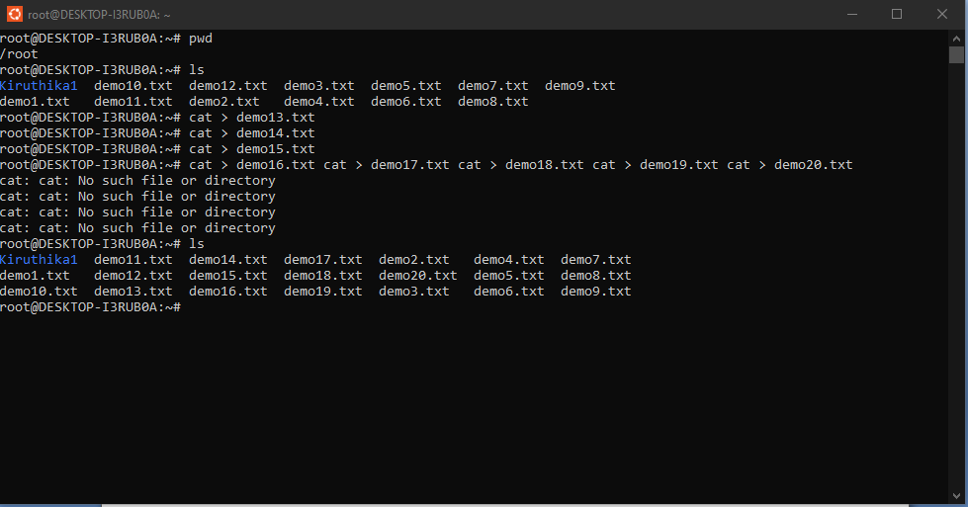

Converting .txt files to .yml extension using rm command

